ASSIGNMENT 4
4 – DIGIT SEVEN SEGMENT DISPLAY
Design
In this design, all the four anodes of the seven segment display are connected by a timing circuit which results in the activation of all the LEDs.
Four 4:1 MUX are used and one 2:1 Decoder and a timing circuit is used to decide which output will be displayed on which anode.

TIMING CIRCUIT
The frequency of the given clock is 1 MHz which is to be reduced in the range 250 Hz to 4 kHz.
For this purpose, we need 16 toggle flip flops to form a synchronous counter which will reduce the given frequency by a factor of 2^16. Hence the frequency of the circuit is reduced.
` Only one LED lights at a time but the gap between lighting of these LEDs is so minimal that we cannot observe it. And we see all the LEDs light up at the same time.

Last two adjacent outputs from the timing circuits are taken as S0 and S1. The frequency of these two differ by a factor of two. In a complete cycle, these two take all the possible set of values which is 00, 01, 10 ,11. where corresponding to 00, anode 0 lights up and corresponding to 01, anode 1 lights up and so on.

DESIGN LIMITATION:
1. A large number of flip-flops is used to reduce the frequency which is not cost effective.
2. This display is limited to displaying only 16 hexadecimal characters.

TEST CASES:
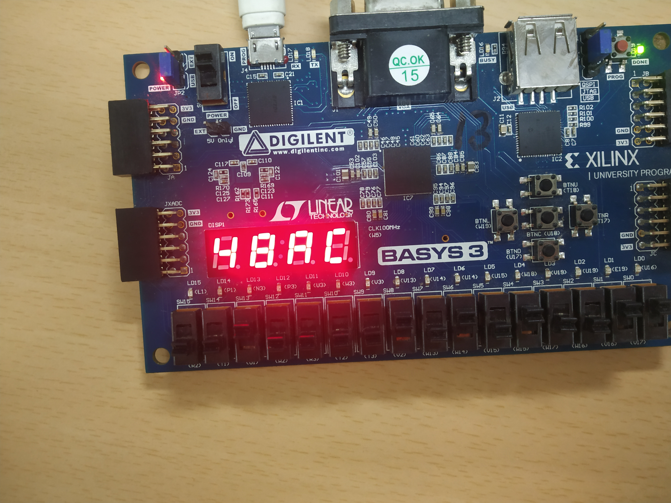
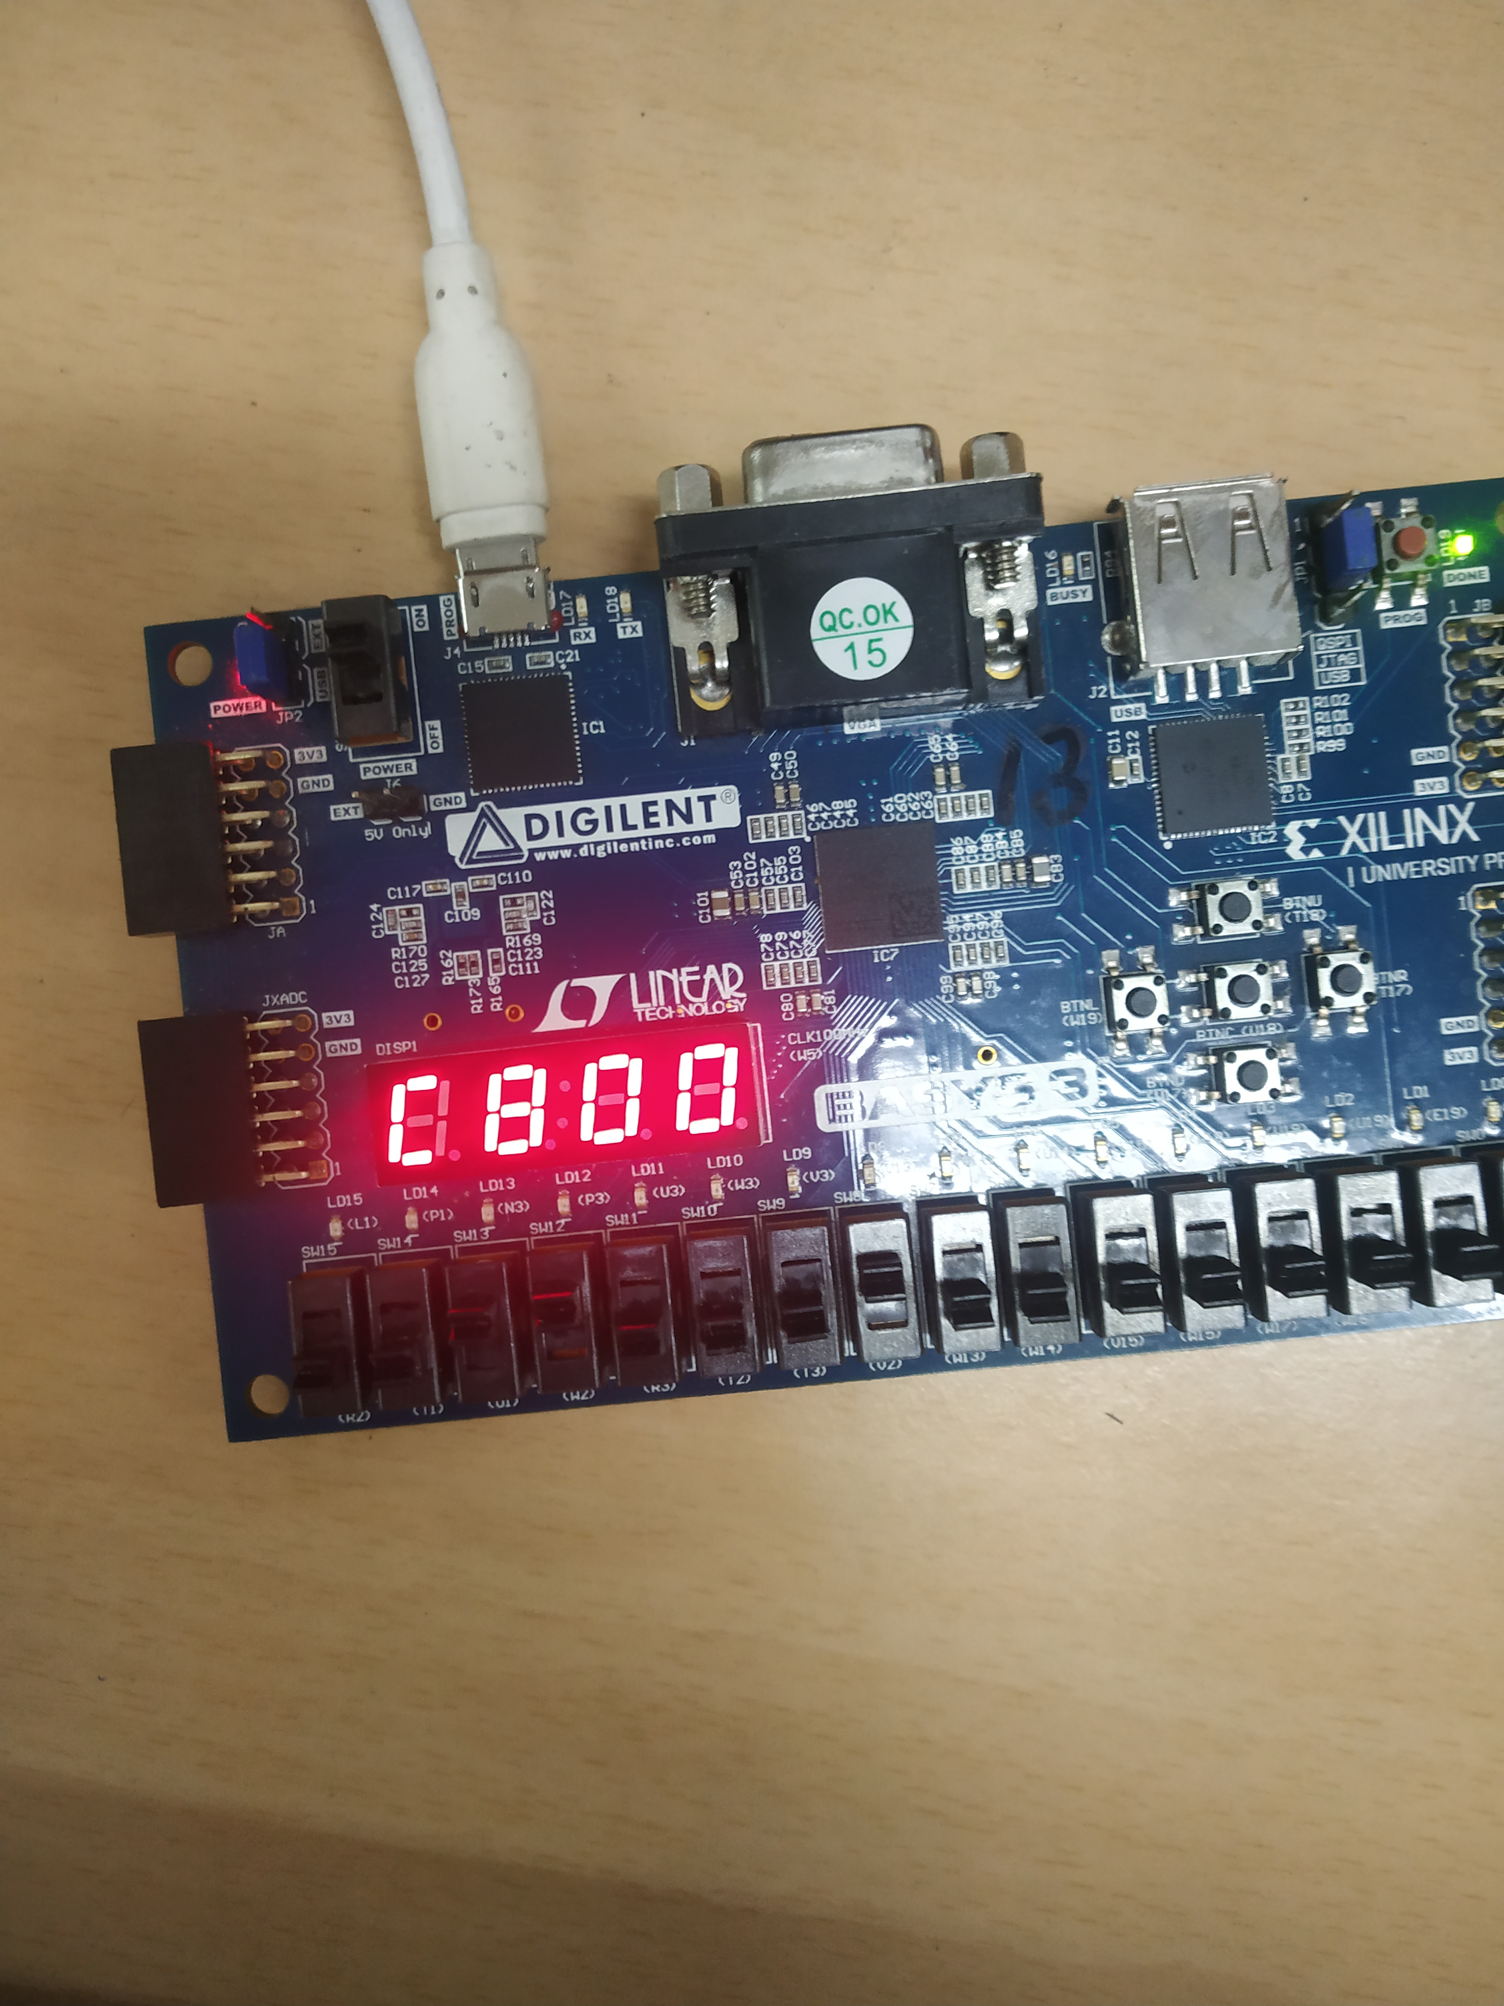

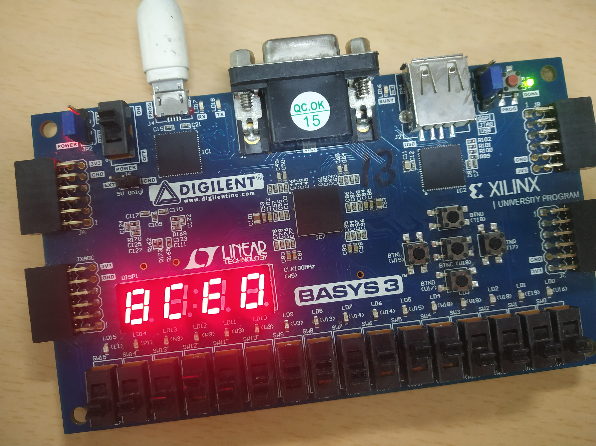

By
Manoj Kumar 2018CS50411
Nikita Bhamu 2018CS50413

